近期准备导入新快门供应商，预期将给客户带来更好的品质体验，新快门模组尺寸相比过去有所变化（右：旧快门，左：新快门），详见工程图纸（分别用old和new标注）：

We are preparing to import a new shutter supplier recently, which is expected to bring customers better quality experience. The size of the new shutter module has been changed compared with the past (right: old shutter, left: new shutter), please refer to the engineering drawings (marked with old and new respectively) :

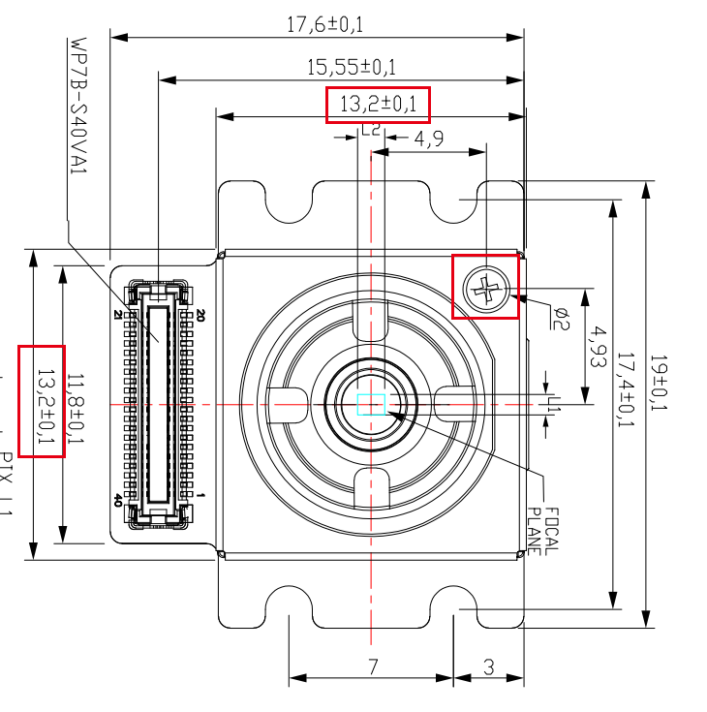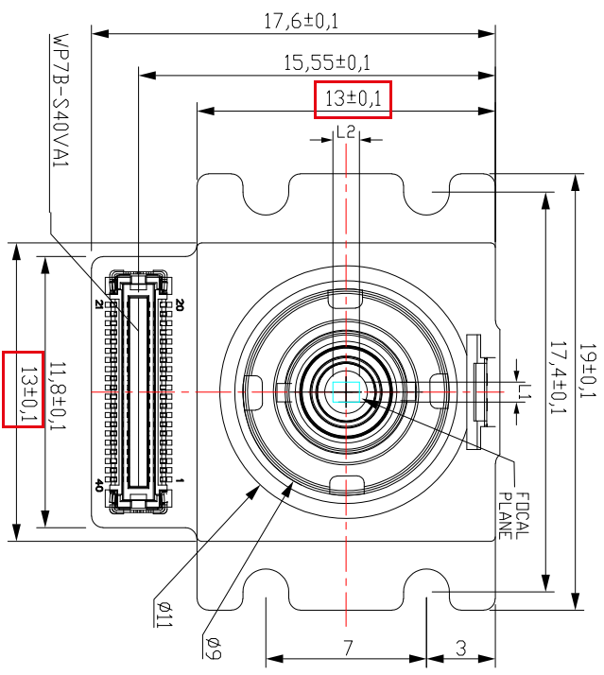

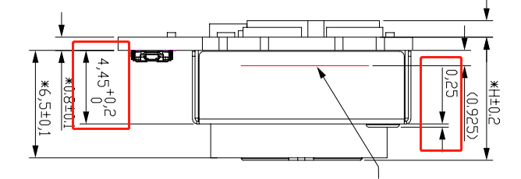 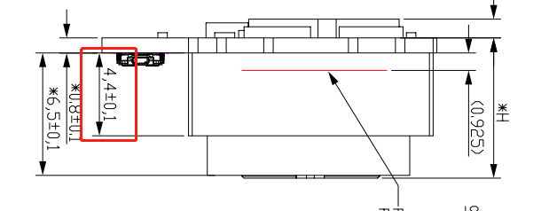

变更部分如红框标注，建议客户在结构设计时增大余量，做好兼容。

The changed part is marked in red box. It is suggested that customers increase the margin and make compatibility in structural design.

